
Sri Lanka continues cricket
Latest headlines
Tour in Pakistan.



Pakistan’s 27th Constitutional Amendment passed

French football team plays Ukraine, 10 years to the day after November 13 attacks



Notable Recent / Upcoming Electric Car Launche
JMEV
Alight (Pakistan)

I phone 17 pro Apple has quietly fixed an Apple Intelligence bug on iPhone 17

In the 2025 AVC Women’s Nations Cup, the Philippines (Alas Pilipinas) won a gritty four-set match against Indonesia

The price of gold in Pakistan dropped sharply on Nov 18, 2025,
In Islamabad, at least 12 people were killed and 27+ wounded in a suicide bombing near the district court.
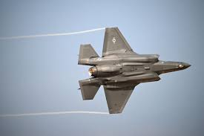
The US may sell F-35 fighter jets to Saudi Arabia, according to President Trump.
Pakistan’s unemployment is rising sharply, with many educated youth unable to find jobs; inflation is worsening poverty.


The government increased the price of high-speed diesel by Rs 6 per liter in mid-November 2025.
Pakistan’s Central Bank is likely to keep its key interest rate at 11%, citing cautious inflation outlook

The military says 15 militants were killed in two counterterrorism operations in Khyber Pakhtunkhwa.
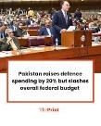
Pakistan beat Sri Lanka in the second ODI (Rawalpindi) to seal the three-match series, despite recent security concerns
Despite the increase in defence spending, Pakistan’s overall federal spending was cut by 7% in the same budget

Two new judges joined this new court.
The first Chief Justice of the new court is Justice Aminuddin Khan.
Pakistan increased its defence (army) budget by 20%.

judges of the new court can work until age 68
Pakistan plans to buy new weapons, including more advanced jets.

Some people say the amendment gives too much power to the military.
Pakistan’s central bank has capped cash purchases of US dollars at $500 to limit capital outflows and stabilize the rupee.
A new office, Chief of Defence Forces (CDF), is being created; the post of Chairman Joint Chiefs of Staff Committee (CJCSC) will be abolished.
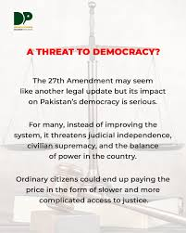The 27th Amendment has been officially challenged in the Supreme Court by a lawyer, citing threats to judicial independence
Two Supreme Court judges — Mansoor Ali Shah and Athar Minallah — resigned after the 27th Amendment, saying it “diminished” the Supreme Court.
MG Lounge is the flagship showroom of MG (Morris Garages) in Pakistan.
MG Lounge sells a variety of MG models, including electric vehicles like the MG ZS-EV and MG4 Electric, as well as hybrid models



A suicide bomber killed 12 people and injured 36 in a blast outside the district court building in Islamabad’s G-11 area.
Youth activists at COP30 in Brazil demand a “full, fast, fair fossil phase-out” amid a draft climate text on fossil fuel transition. The Guardian

A Pakistani high court ordered the illegal raid police to stop harassing an Indian Sikh woman who converted to Islam and married a Pakistani man, after allegations of undue pressure and an.
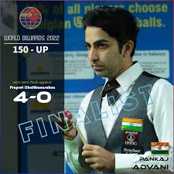
Pakistani cueist Asjad Iqbal stunned three-time champion Pankaj Advani with a 4-0 victory in the quarter-finals of the Snooker World Cup.

International Finance Corporation (IFC) and Standard Chartered Pakistan announced a $400 million risk-participation facility to support working-capital and trade financing for local Pakistani companies.

